THE PHOENIX: A Tale of Reinvention and Rebirth (Non-Fiction)

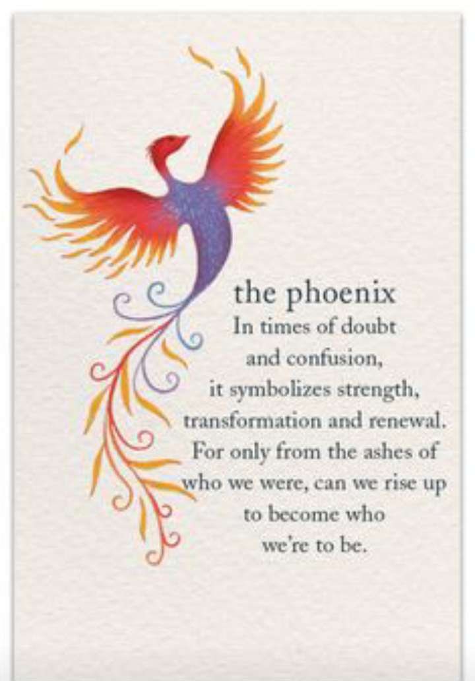I can't continue to live my life like this! I sobbed while gazing up at the ceiling in tears. Since I graduated from secondary school in 2017, I have stayed home and done nothing because I lack the funds to attend university or even learn a skill. I had the best parents, but it was time for me to move on in life without anyone's support because my siblings were still enrolled in secondary school. I then made the decision not to let depression stop me. With or without the help of my family or friends, I was determined to transform my life.

Just like the phoenix I wanted a new life by rising from the ashes into light.

So I traveled to the city of Lagos in search of greener pastures. I arrived in Lagos 2018 alone to apply for a housekeeping job, which I got. Moving to Lagos was a form of reinvention for me as I got to start a new life in an entirely different environment with different people, but I never knew this was just the beginning of my story to rebirth.

Settled in Lagos was a young girl called Ruth, hmmmm ... story of my life, I had a difficult time adjusting to Lagos' way of life because it was the first time I had ventured outside of my comfort zone in an effort to live above mediocrity. Thoughts of regret over having come crossed my thoughts, but one thing was certain: I wouldn't return to my village until I had achieved my aim. I came to Lagos with the intention of saving money to further my education, but guess what? I'm sure you'd assume that this was the last step and I had saved enough money to further my studies, I'm sorry to burst your bubbles, but I sent the entire sum of money back to my people in the village, my life has been what some Nigerians would say: "This life has no balance."

I struggled in Lagos for about two years in vain, so in 2020 I made a decision to return to the village I fled, spent a few months there and returned to Lagos. Then it occurred to me that what needed to change was not the environment but rather my perspective(mindset). I decided to embark on a journey of self-discovery. My thinking, character, relationships, and entire existence underwent a rebirth, as a result of this newfound journey. I was transformed from that depressed and helpless young girl in the ashes to a lady that now shines her light so brightly for others to see.

We (humans) regenerate ourselves by burning and emerging from the ashes to live through another cycle, just like the Phoenix (a unique bird). Reinvention and rebirth makes up our entire living from the moment we were born to the moment we pass away.

Live, rebirth, and reinvent like the "Phoenix".

…..The End

