THE PHOENIX:
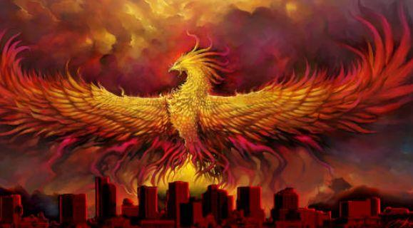
THE TALE OF REINVENTION
AND
REBIRTH
(Fiction)

Iye Nice Atuluku

I have lived a thousand lives, yet this rebirth feels different. For centuries, I soared gloriously, spreading my wings and lighting my world with my radiance. But then, as with all things, the circle came to an end. I fell to the ground in flames, consumed by my own fiery nature. The ashes of my former glory settled around me, marking the end of my existence as I had known it. But even in the darkness, I felt a stirring within me; a call to something new.


The fire around me sizzled. My ashes swirled. At first, I fought against it, struggling to hold on to what was left of my identity. But as I surrendered, embracing the transformative fire and allowing it to purify my essence and rid me of my former limitations, something miraculous began to occur. The ashes around me shifted, reorganizing themselves into a new form. I felt a warmth spreading within my entirety. I could not tell if it was hope or something more transformative. I watched the last vestiges of my old self gradually fade away and I felt a surge of indescribable power course through my veins.

My body, now aglow with light, transformed into something unimaginable. Feathers sprouted from my skin, shimmering in vibrant shades of red and gold. And with a burst of energy, I leapt up into the sky, higher and faster than I had ever before. I knew I had been given a second chance; an opportunity to rise from the ashes of my past and become something entirely new.
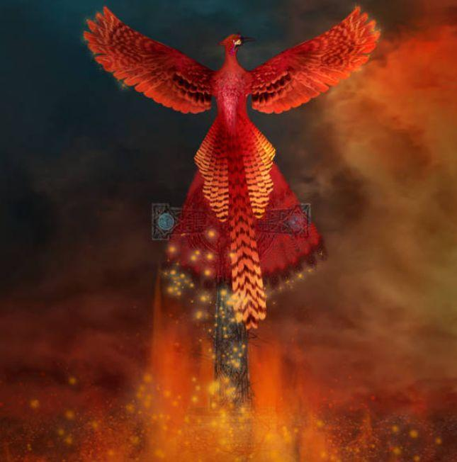

As I soared higher and higher towards the sun, I glowed with beauty. The weight of my old self slowly dissipated, leaving me with a newfound sense of freedom. I let go of regrets, failures, doubts, past mistakes, and all that had held me back, as if shedding my old feathers. The fire that once consumed me now fueled the passion that guided me forward.

Soon, I became a beacon of light to those who had forgotten their own inner radiance. As time passed by, my name echoed through ages. Egypt, China, Greece, and almost all nations of the earth admired and retold my tale. My pictures were found on coins, shields, and flags. And although I'm not an actor, I was metaphorically represented in Shakespeare's The Tempest, and was featured in Harry Potter. Even Arizona was inspired to rename its capital after me. So, I continued to soar, spreading hope and inspiration to many at their dead ends.

I am the Phoenix; the embodiment of resilience. And I hope you always find inspiration to forge ahead from my tale of reinvention and rebirth.

Kindly click on the link below to read my Facebook version of the above tale:

The Chinaza Favour Writing Challenge 2023.

