The Phoenix: A Tale of Reinvention and Rebirth (Fiction)

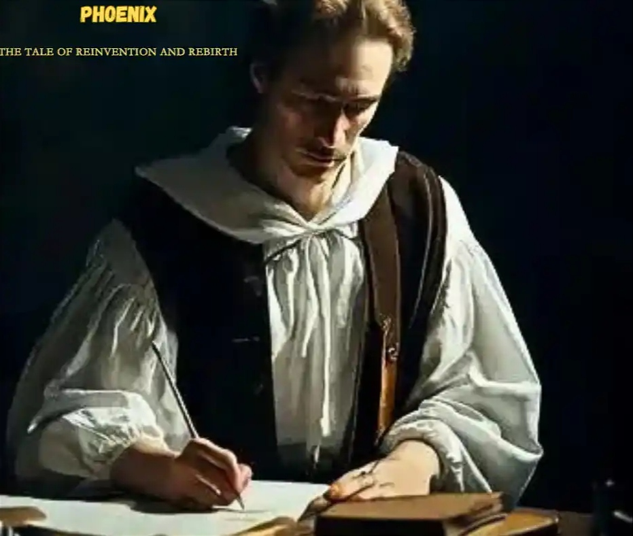

Once upon a time, in a quaint village nestled among rolling hills, there lived a young boy named Oliver. His heart was filled with dreams that danced like fireflies, illuminating his path through life. Oliver possessed a wild imagination that whisked him away to distant lands and magical realms. However, the harsh realities of the world often dimmed his light, casting shadows of doubt upon his spirit.

Oliver’s family struggled to make ends meet, and their home was a small cottage on the outskirts of the village. Yet, despite their hardships, they nurtured the flame of hope within the young boy. They encouraged his dreams and reminded him that within every challenge lay an opportunity for growth.

One fateful day, as Oliver wandered through the village, he stumbled upon an old, dusty bookshop. Drawn by the whispers of adventure that lingered within, he stepped inside. The air was heavy with the scent of aged parchment and ink. The shopkeeper, a kind old man with wise eyes, greeted Oliver warmly.

“Welcome, young adventurer,” he said. “What brings you to this humble abode of tales?”

Oliver’s eyes sparkled with excitement as he shared his dreams of becoming a writer, weaving stories that would captivate the hearts of readers far and wide. The shopkeeper listened intently, his eyes shining with recognition.

“You possess a gift, young Oliver,” he said.
“Stories have the power to shape destinies and breathe life into the ordinary. But remember, to be a great writer, you must first live a great story.”

Intrigued by the shopkeeper’s words, Oliver embarked on a journey of self-discovery. He ventured into the depths of the forest, scaling mountains and transversing treacherous rivers. He met kind souls who shared their wisdom and encountered adversaries who tested his resolve.

With each experience, Oliver grew stronger, both in body and spirit. He discovered that stories were not merely figments of imagination but reflections of the human experience. He realized that to create stories that resonated, he must first understand the complexities of life and embrace the full spectrum of emotions.

Years passed, and Oliver returned to his village, a changed young man. The dreams that once seemed distant now burned brightly within him. He set out to write his masterpiece, pouring his heart and soul onto the pages, crafting characters with depth and resonance. His words painted vivid landscapes, evoking laughter, tears, and introspection.

Word of Oliver’s talent spread like wildfire, reaching the far corners of the world. Publishers clamoured for his stories, eager to share his gift with everyone. His words touched the hearts of countless readers, inspiring them to dream, to believe, and to embrace the power of reinvention and rebirth.

Oliver’s journey from a young boy filled with dreams to a celebrated author became a testament to the human spirit’s boundless potential. He proved that within every setback lies an opportunity for growth, and that the power to transform one’s life resides within.

And so, dear reader, as you close this tale of reinvention and rebirth, remember that your own story is waiting to be written. Embrace the challenges, for they are the crucible in which your character is forged. Let your imagination soar and your dreams guide you, for within the realm of possibilities, the extraordinary is born.

The end.

©️ Favour

#ChinazaWorital #ThePhoenixWritingChallenge #ChinazaFavoursWritingChallenge2023

